**Class:** Final Year (Computer Science and Engineering)

**Year:** 2021-22 **Semester:** 1

**Course:** High Performance Computing Lab

**Practical No. 7**

**Exam Seat No:**

1. 2018BTECS00088 – Abhishek Bhagate

**Problem Statement 1:**

Q1: Setup the environment requirements, for execution of CUDA C programs..

**Screenshot 1:**

**Information 1:**

Download the CUDA toolkit from the Nvidia website - <https://developer.nvidia.com/cuda-downloads>.

**Screenshot 2:**

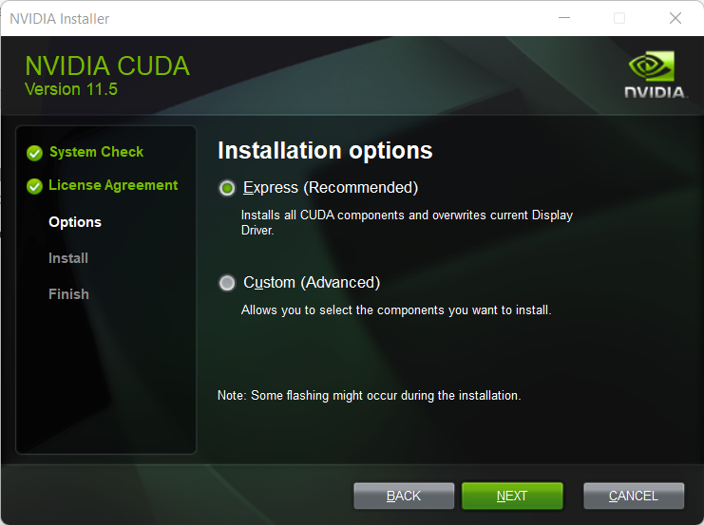

**Information 2:**

Run the setup and install CUDA and related tools on your system

**Screenshot 3:**

**Information 3:**

Download the Visual Studio 2019 and install it the option desktop development with C++. Once this is completed, all the CUDA and related tools are installed successfully on your system and you can run any CUDA program.

**Problem Statement 2:**

Q2. Execute the attached Program 1, and understand the output.

**Screenshot 1:**

**Information 1:**

The program shows various information about our GPU. First one is the amount of shared memory per block which the threads can use for inter-thread communication. In this case, the maximum amount is 49152 bytes = 48KB.

The 2nd information is about number of registers per block which is 65536. These registers are used by threads to store variables and access at high speed

The 3rd is warp size equal to 32 which is the number of threads that a multiprocessor executes concurrently.

The 4th information gives the total multiprocessor on device which is equal to 24

The 5th one is the number of threads in each block which is limited to 1024

The 6th one gives the dimensions of a block which can be 1024 x 1024 x 64. The dimension size of a block must be such that the total number of threads remains less than or equal to 1024.

The 7th metric shows the dimensions of grid which consists of blocks which in this case is 2147483647 x 65535 x 65535.

The 8th one gives the Maximum pitch in bytes allowed by memory copies which is 2147483647 bytes=2MB in this case.

The final information is about clock rate which shows the memory speed on the GPU which in this case is 1590 Mhz.

**Problem Statement 3:**

Q3. Write a CUDA C program to perform the addition of two vectors of arbitrary size(Dynamic Array).

**Screenshot 1 (Upto 16 processes):**

**Information 1:**

The above program takes size of dynamic array and inputs the element into the array. Then it performs parallel addition by transferring the vector to device memory and launching the kernels. Each thread adds one element of vector in parallel.

**Github Link:**

https://github.com/archit81/HPC-Lab-Assignments/tree/main/Assignment%20-%20VII